

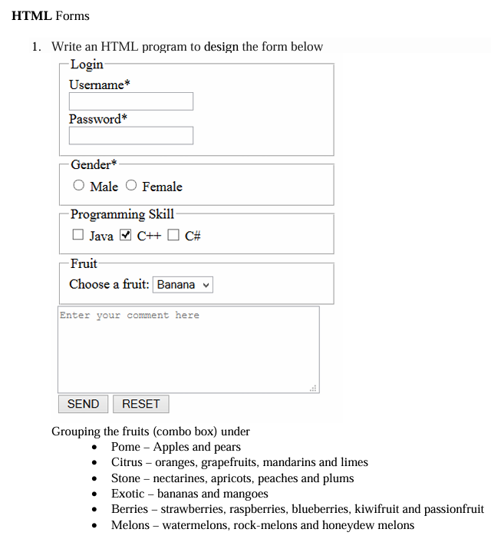

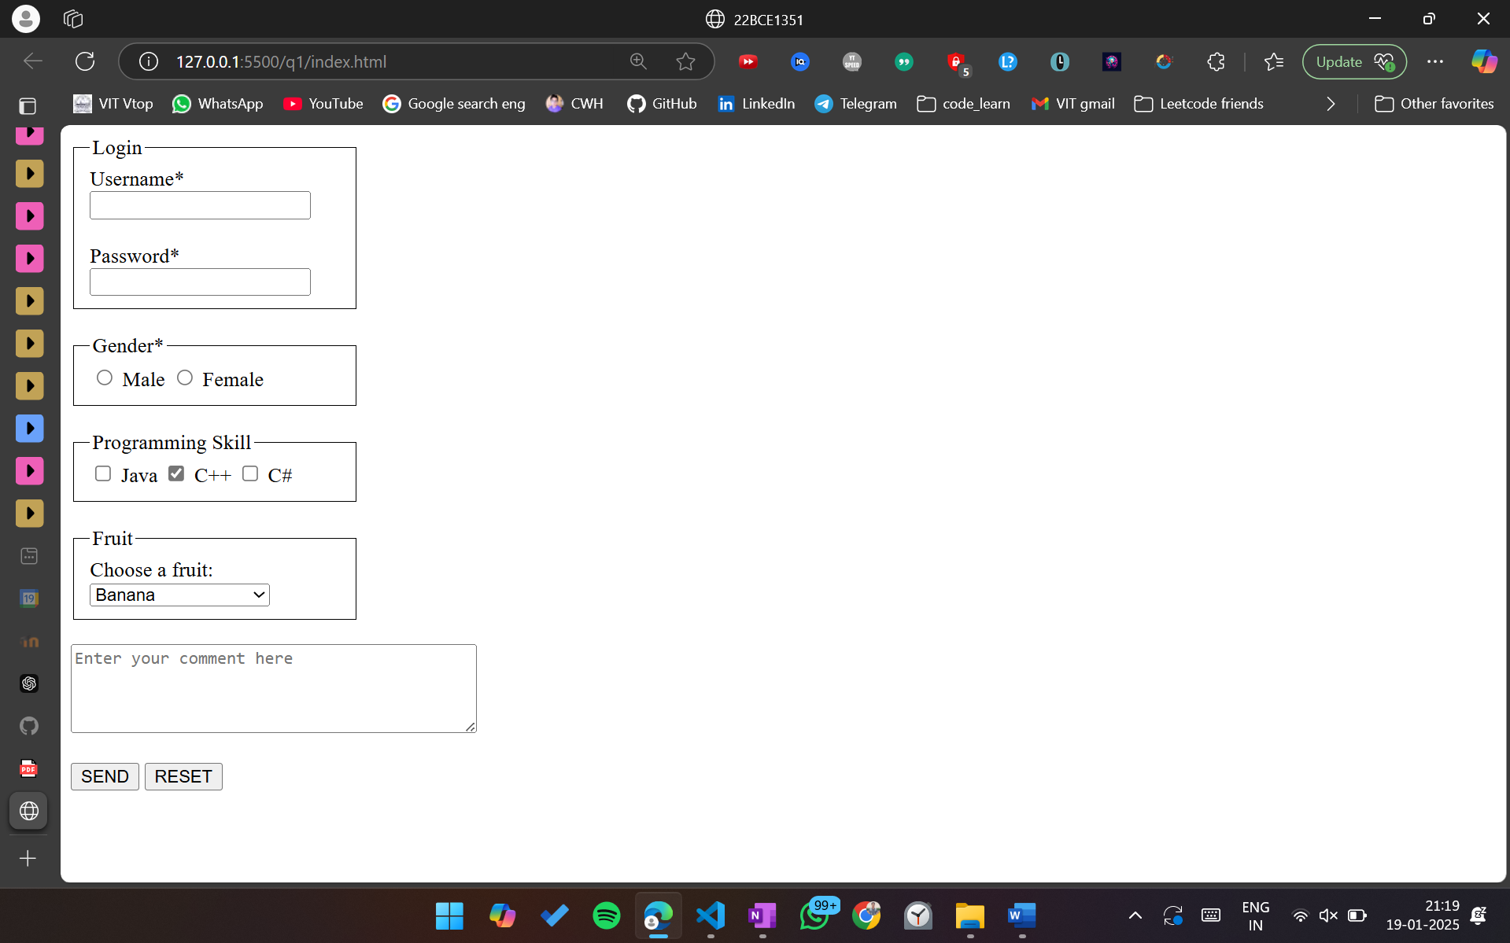

<!DOCTYPE html>

<html lang="en">

<head>

    <meta charset="UTF-8">

    <meta name="viewport" content="width=device-width, initial-scale=1.0">

    <title>22BCE1351</title>

    <style>

        fieldset {

            border: 1px solid black;

            margin-right: 80%;

        }

    </style>

</head>

<body>

    <form>

        <fieldset>

            <legend>Login</legend>

            <label for="username">Username*</label><br>

            <input type="text" id="username" name="username" required><br><br>

            <label for="password">Password*</label><br>

            <input type="password" id="password" name="password" required>

        </fieldset>

        <br>

        <fieldset>

            <legend>Gender*</legend>

            <input type="radio" id="male" name="gender" value="male" required>

            <label for="male">Male</label>

            <input type="radio" id="female" name="gender" value="female" required>

            <label for="female">Female</label>

        </fieldset>

        <br>

        <fieldset>

            <legend>Programming Skill</legend>

            <input type="checkbox" id="java" name="skill" value="java">

            <label for="java">Java</label>

            <input type="checkbox" id="cpp" name="skill" value="cpp" checked>

            <label for="cpp">C++</label>

            <input type="checkbox" id="csharp" name="skill" value="csharp">

            <label for="csharp">C#</label>

        </fieldset>

        <br>

        <fieldset>

            <legend>Fruit</legend>

            <label for="fruit">Choose a fruit:</label>

            <select id="fruit" name="fruit">

                <optgroup label="Pome">

                    <option value="apple">Apple</option>

                    <option value="pear">Pear</option>

                </optgroup>

                <optgroup label="Citrus">

                    <option value="orange">Orange</option>

                    <option value="grapefruit">Grapefruit</option>

                    <option value="mandarin">Mandarin</option>

                    <option value="lime">Lime</option>

                </optgroup>

                <optgroup label="Stone">

                    <option value="nectarine">Nectarine</option>

                    <option value="apricot">Apricot</option>

                    <option value="peach">Peach</option>

                    <option value="plum">Plum</option>

                </optgroup>

                <optgroup label="Exotic">

                    <option value="banana" selected>Banana</option>

                    <option value="mango">Mango</option>

                </optgroup>

                <optgroup label="Berries">

                    <option value="strawberry">Strawberry</option>

                    <option value="raspberry">Raspberry</option>

                    <option value="blueberry">Blueberry</option>

                    <option value="kiwifruit">Kiwifruit</option>

                    <option value="passionfruit">Passionfruit</option>

                </optgroup>

                <optgroup label="Melons">

                    <option value="watermelon">Watermelon</option>

                    <option value="rockmelon">Rock-melon</option>

                    <option value="honeydew">Honeydew Melon</option>

                </optgroup>

            </select>

        </fieldset>

        <br>

        <textarea id="comments" name="comments" rows="4" cols="40" placeholder="Enter your comment here"></textarea>

        <br><br>

        <button type="submit">SEND</button>

        <button type="reset">RESET</button>

    </form>

</body>

</html>



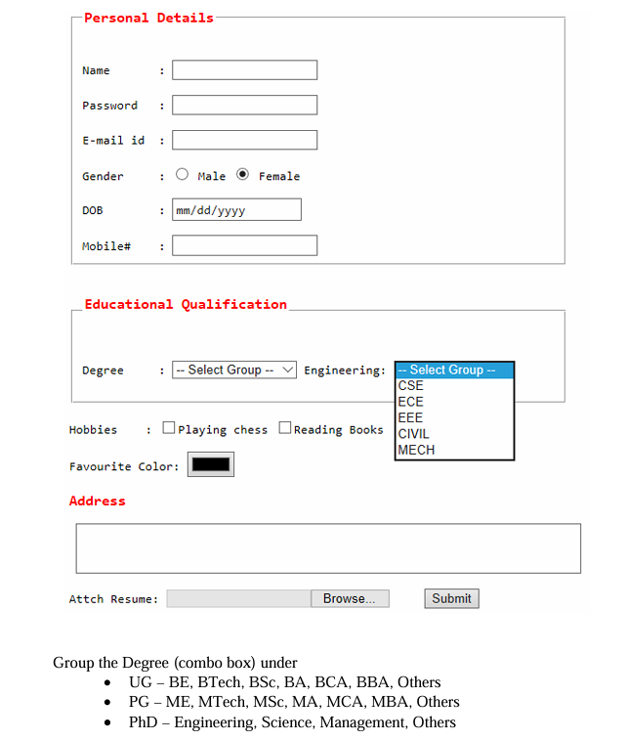

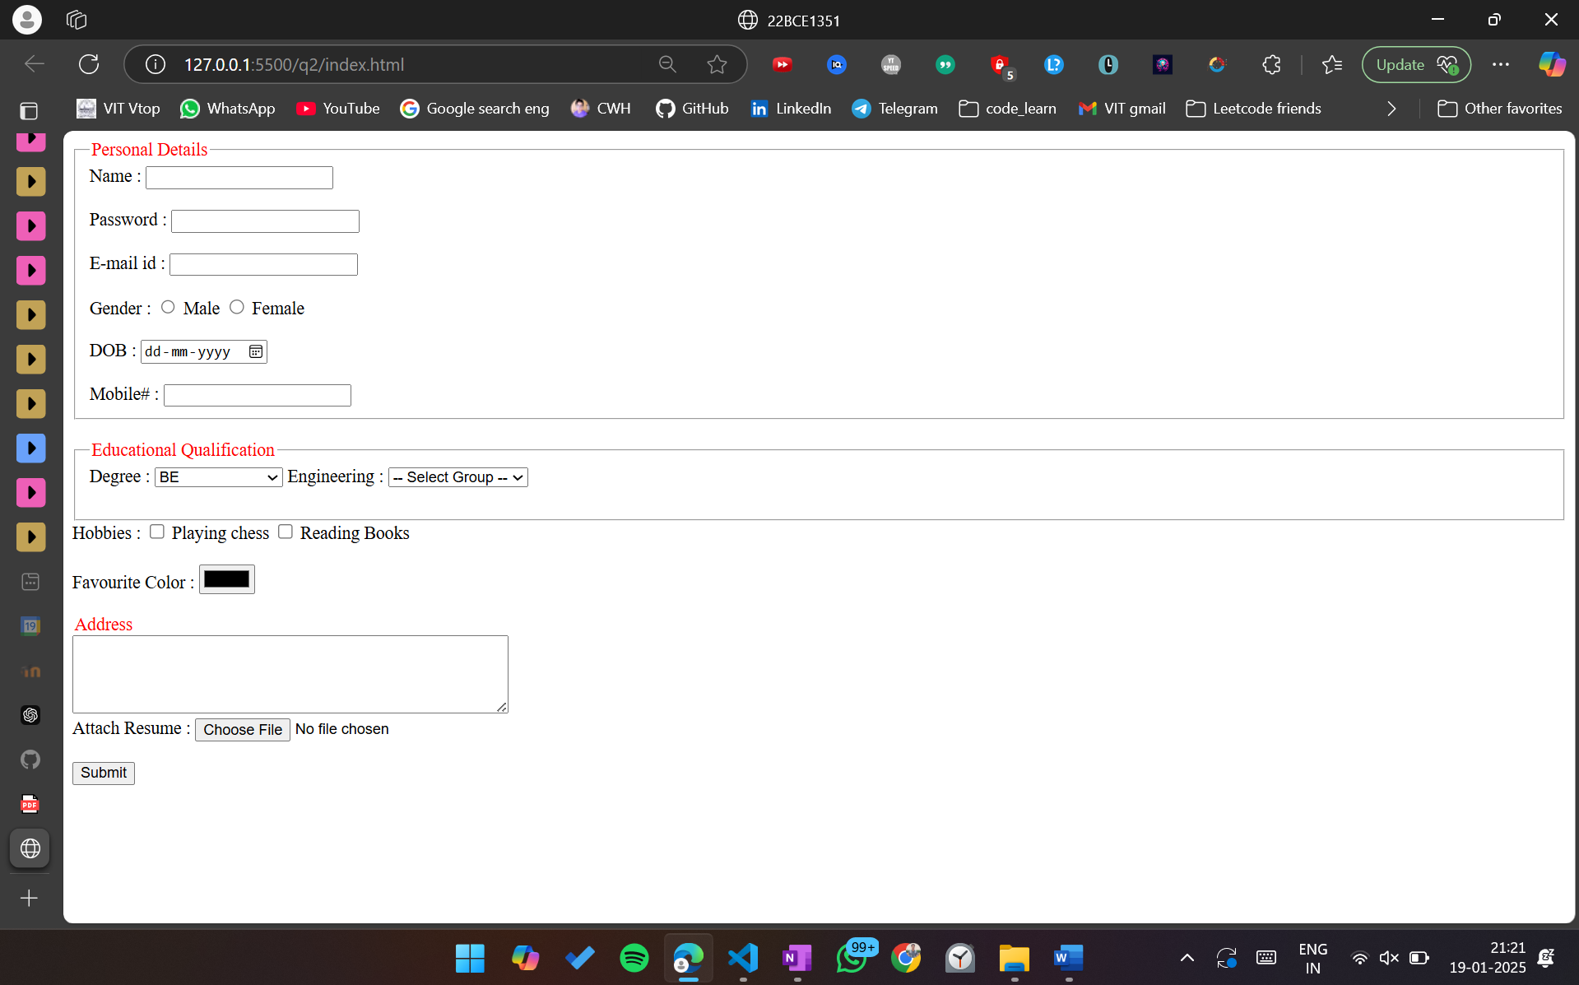

<!DOCTYPE html>

<html lang="en">

<head>

    <meta charset="UTF-8">

    <meta name="viewport" content="width=device-width, initial-scale=1.0">

    <title>22BCE1351</title>

</head>

<body>

    <form>

        <fieldset>

            <legend style="color: red;">Personal Details</legend>

            <label for="name">Name :</label>

            <input type="text" id="name" name="name" required><br><br>

            <label for="password">Password :</label>

            <input type="password" id="password" name="password" required><br><br>

            <label for="email">E-mail id :</label>

            <input type="email" id="email" name="email" required><br><br>

            <label>Gender :</label>

            <input type="radio" id="male" name="gender" value="male" required>

            <label for="male">Male</label>

            <input type="radio" id="female" name="gender" value="female" required>

            <label for="female">Female</label><br><br>

            <label for="dob">DOB :</label>

            <input type="date" id="dob" name="dob" required><br><br>

            <label for="mobile">Mobile# :</label>

            <input type="tel" id="mobile" name="mobile" pattern="[0-9]{10}" required>

        </fieldset>

        <br>

        <fieldset>

            <legend style="color: red;">Educational Qualification</legend>

            <label for="degree">Degree :</label>

            <select id="degree" name="degree">

                <optgroup label="UG">

                    <option value="be">BE</option>

                    <option value="btech">BTech</option>

                    <option value="bsc">BSc</option>

                    <option value="ba">BA</option>

                    <option value="bca">BCA</option>

                    <option value="bba">BBA</option>

                    <option value="ug_others">Others</option>

                </optgroup>

                <optgroup label="PG">

                    <option value="me">ME</option>

                    <option value="mtech">MTech</option>

                    <option value="msc">MSc</option>

                    <option value="ma">MA</option>

                    <option value="mca">MCA</option>

                    <option value="mba">MBA</option>

                    <option value="pg_others">Others</option>

                </optgroup>

                <optgroup label="PhD">

                    <option value="engineering">Engineering</option>

                    <option value="science">Science</option>

                    <option value="management">Management</option>

                    <option value="phd_others">Others</option>

                </optgroup>

            </select>

            <label for="engineering">Engineering :</label>

            <select id="engineering" name="engineering">

                <option value="">-- Select Group --</option>

                <option value="cse">CSE</option>

                <option value="ece">ECE</option>

                <option value="eee">EEE</option>

                <option value="civil">CIVIL</option>

                <option value="mech">MECH</option>

            </select><br><br>

        </fieldset>

        <label>Hobbies :</label>

        <input type="checkbox" id="chess" name="hobby" value="chess">

        <label for="chess">Playing chess</label>

        <input type="checkbox" id="books" name="hobby" value="books">

        <label for="books">Reading Books</label><br><br>

        <label for="color">Favourite Color :</label>

        <input type="color" id="color" name="color">

        <br>

        <br>

        <legend style="color: red;">Address</legend>

            <textarea id="address" name="address" rows="4" cols="50"></textarea>

        <br>

        <label for="resume">Attach Resume :</label>

        <input type="file" id="resume" name="resume" accept=".pdf,.doc,.docx"><br><br>

        <button type="submit">Submit</button>

    </form>

</body>

</html>



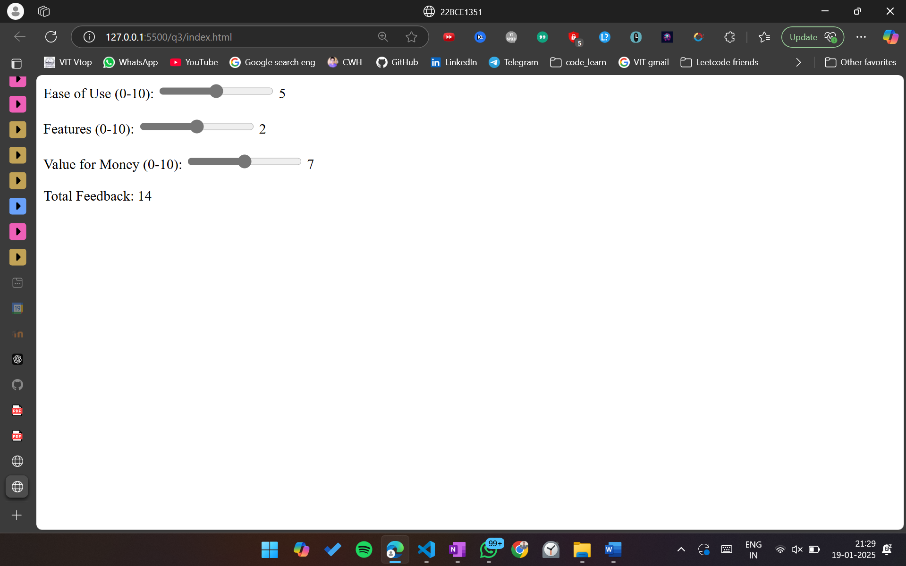

Index.htnl

<!DOCTYPE html>

<html lang="en">

<head>

    <meta charset="UTF-8">

    <meta name="viewport" content="width=device-width, initial-scale=1.0">

    <title>22BCE1351</title>

</head>

<body>

    <form>

        <label for="slider1">Ease of Use (0-10):</label>

        <input type="range" id="slider1" name="easeOfUse" min="0" max="10" value="5" oninput="calculateTotal()">

        <output id="output1" for="slider1">5</output>

        <br><br>

        <label for="slider2">Features (0-10):</label>

        <input type="range" id="slider2" name="features" min="0" max="10" value="5" oninput="calculateTotal()">

        <output id="output2" for="slider2">2</output>

        <br><br>

        <label for="slider3">Value for Money (0-10):</label>

        <input type="range" id="slider3" name="valueForMoney" min="0" max="10" value="5" oninput="calculateTotal()">

        <output id="output3" for="slider3">7</output>

        <br><br>

        <label for="totalOutput">Total Feedback:</label>

        <output id="totalOutput" name="totalOutput">14</output>

    </form>

    <script src="script.js"></script>

</body>

</html>

Script.js

function calculateTotal() {

    const slider1 = parseInt(document.getElementById("slider1").value);

    const slider2 = parseInt(document.getElementById("slider2").value);

    const slider3 = parseInt(document.getElementById("slider3").value);

    const total = slider1 + slider2 + slider3;

    document.getElementById("totalOutput").value = total;

}

document.getElementById("slider1").oninput = function() {

    document.getElementById("output1").value = this.value;

    calculateTotal();

};

document.getElementById("slider2").oninput = function() {

    document.getElementById("output2").value = this.value;

    calculateTotal();

};

document.getElementById("slider3").oninput = function() {

    document.getElementById("output3").value = this.value;

    calculateTotal();

};

